Kaltura Blackboard Building Block - KAF

Introduction

  - The Kaltura Building Block allows us to add powerful media tools to Blackboard, combining the best features of video sharing, webcam recording, screen recording, and more, all within the Blackboard Learn environment. Creating and sharing multimedia learning content is easier than ever using these intuitive tools.

    - What do I use it for?

      - The Blackboard interface for Kaltura should be used for your original video content created for use in a Blackboard course. That original content includes videos recorded on your smartphone, webcam, or other video device. Other original content could be screencasts or videos created in other programs that you have saved to your computer in the past. There are also several tools now built into Blackboard that will allow you to create screencasts and webcam recordings right within Blackboard.

    - What isn’t Kaltura for?

      - Uploaded media should be your own, original instructional content. It is NOT for other people’s copyrighted works. Additionally, if you already have content in place on other sharing sites (such as YouTube or Vimeo) that you’ve embedded in courses, you may want to leave it where it is, if it’s already functioning correctly. Please contact multimedia@wilmu.edu if you have questions or want to discuss what content should be relocated.
  - The first item to note about the addition of Kaltura to our Blackboard Learn site is the Kaltura Media Tools tab under the Wilmington University tab. (The first screen you see after logon.)
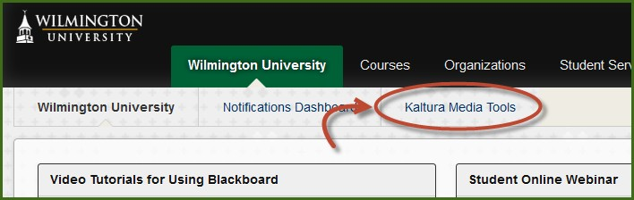
Wilmington University
Created 2015

There you will find tips, tutorial videos, PDF documentation, and more to help you get started with Kaltura. The first two items to note are the modules for My Media and the Faculty Repository.

1

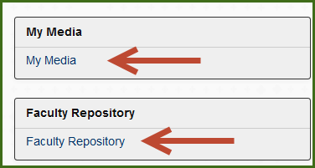

Clicking on them will take you to your personal repository (My Media) or the shared media (Faculty Repository).
  - Interacting with either of these from the Wilmington University tab in Blackboard constitutes an institution level function.

Institution Level Interaction

  - Clicking on My Media before you’re in a course takes to your personal media repository in Blackboard. This is a full list of all media you’ve uploaded or created using Kaltura in any of your Blackboard courses or organizations.

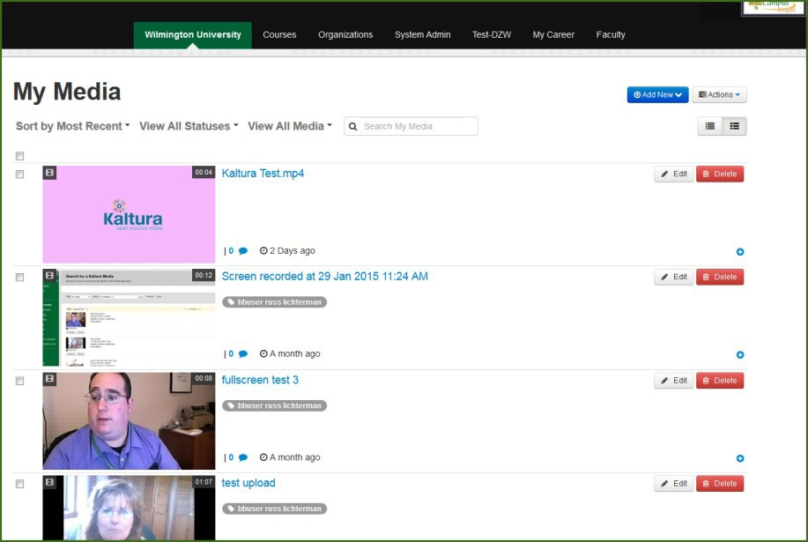
Wilmington University Educational Technology

  - This institution level My Media is one of the places you can create or upload media. Adding any media at the institution level adds it to your personal media repository (My Media) but it will not be associated with any specific course that you teach until you deploy it to a course gallery or insert it into a course item.

Clicking the Add New button allows you upload a file or create new media such as a screen recording, webcam video, or presentation using CaptureSpace.
  - To upload a video file, click Media Upload and browse to the file you want to upload.

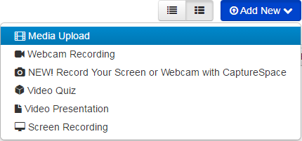

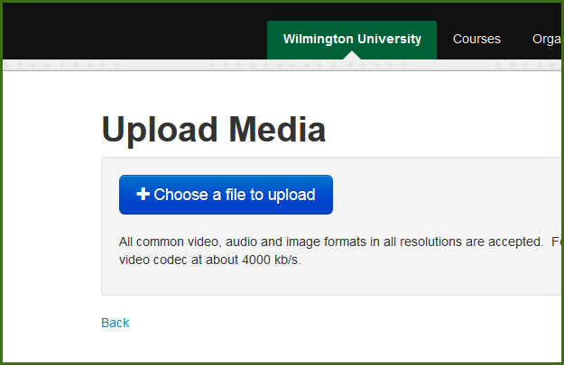
Wilmington University Educational Technology

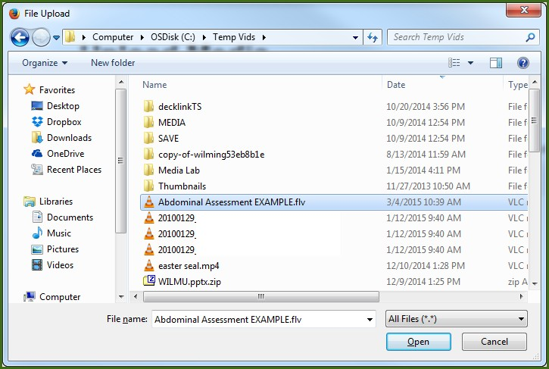

  - Kaltura will upload the file then add it to your institution level media gallery (My Media). You will then have the opportunity to change the title, add tags and other metadata, and more while the video is processing.
Adding accurate tags and descriptions is important because those are fields you can search when you’re looking for a specific video for your course. These are also extremely important if you choose to add your media to the Shared Repository for other instructors to use in their courses.

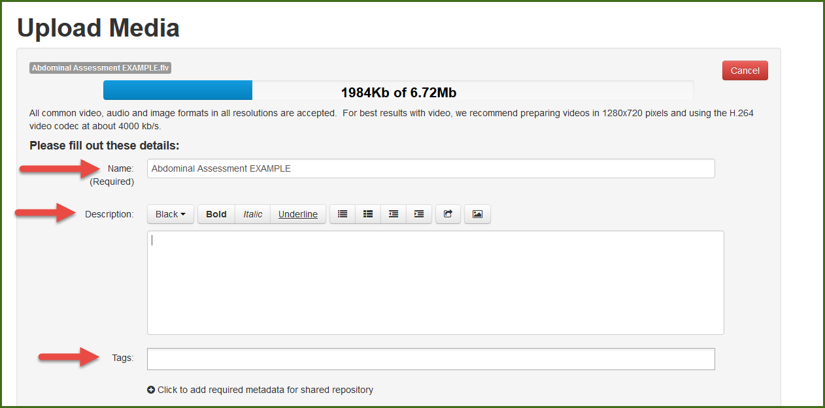

If you want to add this video to the Shared Repository, you can add extra information for the video to be found by other instructors here:

Wilmington University Educational Technology

  - After any video is created or uploaded to the institutional level My Media you will have the option to go back and edit the title, description or tags at any time. You can also choose if you want others to be able to make clips of your video, add the video to the Shared Repository, or add it to a Course Gallery now or at any time in the future.

  - When you’re done, press the Save button then Go To Media to go directly to the video, or
Go To My Media to return to your personal media list.

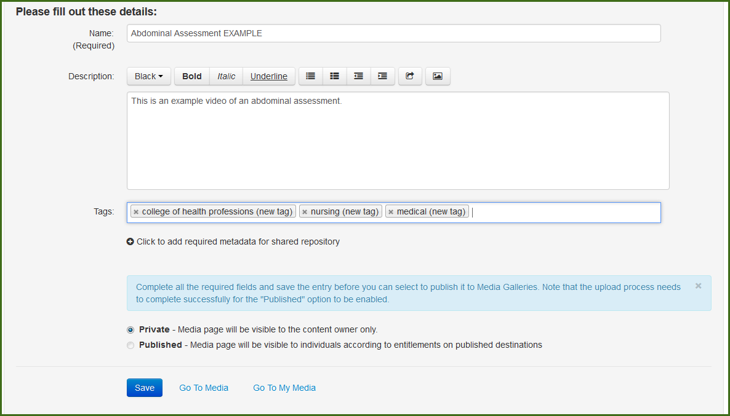
    - Clicking the Action button will allow you to Publish the video to a course gallery,
Edit the video information and metadata, or Delete the video.

Publishing will deploy the video to the gallery in that particular course, but it will always remain in your My Media gallery as well. The course gallery has to be added manually to a course if you want to use it. All the videos in your My Media repository will always be available to you to insert as a course item even if you aren’t using the course gallery.

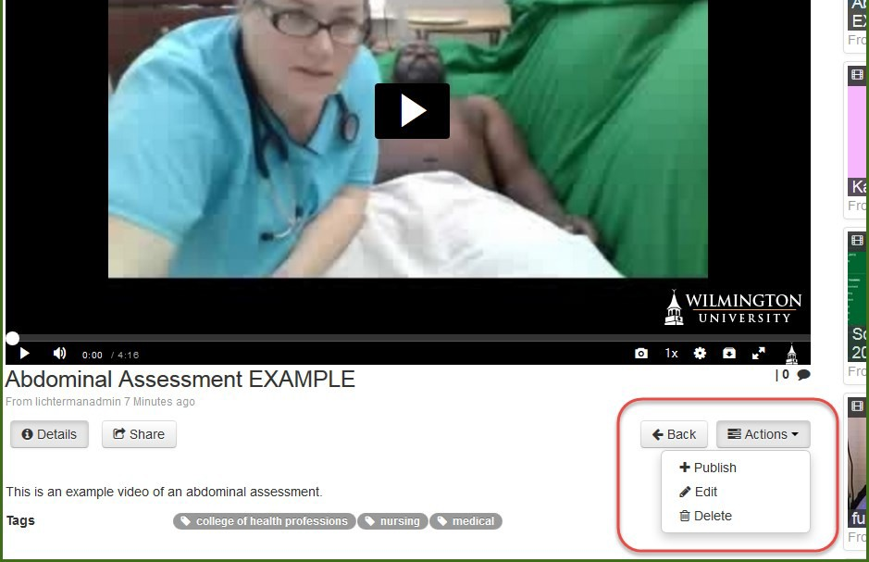
Wilmington University Educational Technology

    - Clicking the edit button will allow you to change any existing metadata for your video, and clicking the link Add Required Metadata for Shared Repository will allow you to share the video with other faculty members at the university. We strongly encourage you to share any instructional content that might be useful in other courses with the Shared Repository.

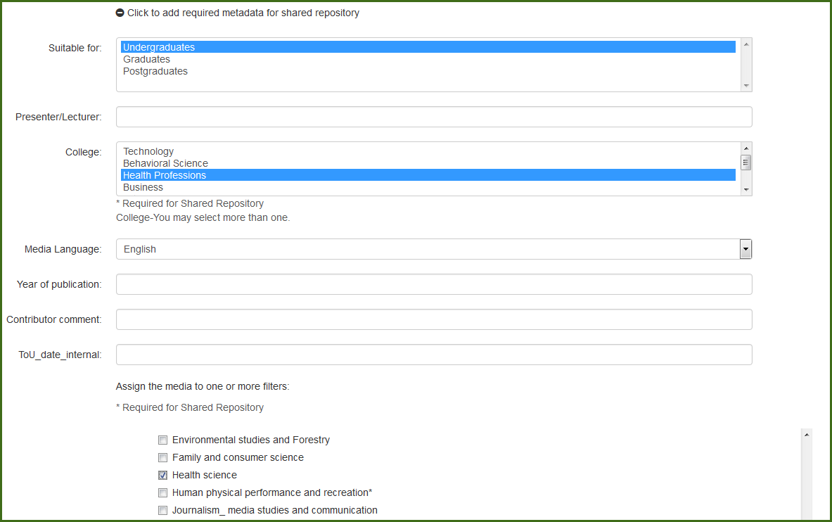

    - There are additional metadata fields you will be asked for when adding to the Shared Repository as well as accepting the terms of use. Accurate metadata will be extremely important for other faculty to find the videos you’ve chosen to share.
    - Please include the college (eg: College of Business) and course number (eg: BUS402) in the tags of any video you create or upload, as well as any other relevant keywords.

    - When you’re done, click the Save button.
Wilmington University Educational Technology

  - The institution level is the only area where you can add videos from My Media to the Faculty Repository. Videos created at the course level cannot be added to the Faculty Repository from the course gallery, but they will appear in your institution level My Media gallery, and can be added from there.

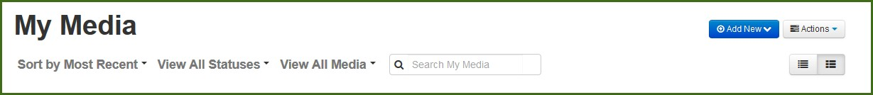
  - The search bar will search the title, tags, and descriptions of all videos based on the parameters you select. These search bars appear in your media gallery at the course level and institution level, as well as the shared repository, and are the reason why accurate tags and descriptions of media is important.
  - You can also record screencasts or record from your webcam. All of these same tools can be accessed at the course level as well. Items uploaded within a course are automatically associated with that course gallery and do not have to be deployed to a particular course, as they do at the institution level.

Record new media
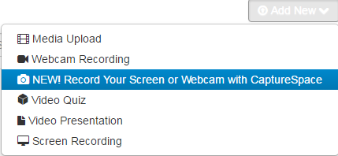
You can record new media from anywhere the Add New button appears. You can create voice recordings, webcam videos, screencasts, and presentations.

Download the Recorder

If you have never used CaptureSpace before, you will need to download the recorder. You will be brought to a download page and you will need to choose the appropriate download for your system.
Wilmington University Educational Technology
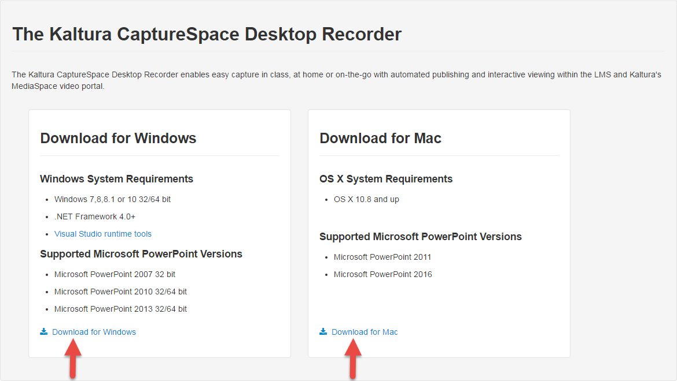

When you get a pop-up choose “Run”

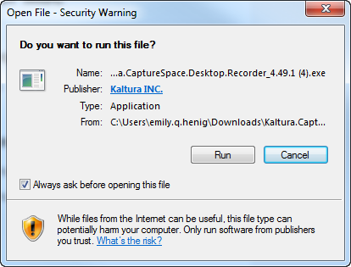
Once the download is complete, the Recorder will launch.

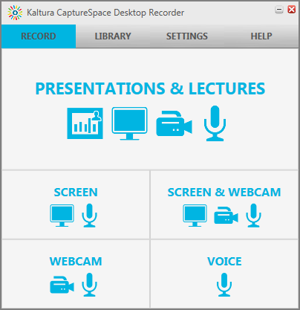

Check your settings to ensure the correct audio and video devices are selected.

Click browse to see where your recordings will be saved. You can save a local copy on your computer or external drive in addition to saving to your Kaltura media storage.
Wilmington University Educational Technology
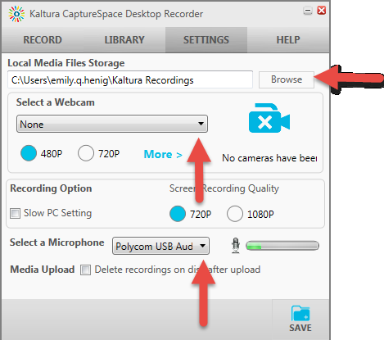

    - Voice Recording

      - The simplest tool offered in the CaptureSpace recorder is the Voice tool
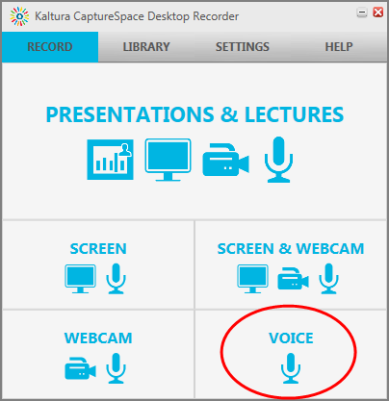
ii. Webcam Recording
      - Click the Voice button and you will be given 5 seconds and then it will begin recording your voice using the device you selected in your settings. You can pause and resume your recording at any time.

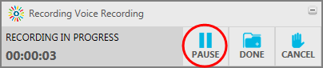
      - Later, you will have the option to trim and crop your video to edit out any mistakes or dead time. Click Done when you are finished.

- If you click the Webcam button, you can record using the camera you selected when you checked your settings. Like the Voice Recorder, you will be given 5 seconds and then your recording will begin.

- Again, here you can pause and resume at any time, if you need a break in your recording.

- Once you are done, click the Done button and you will be given a preview.

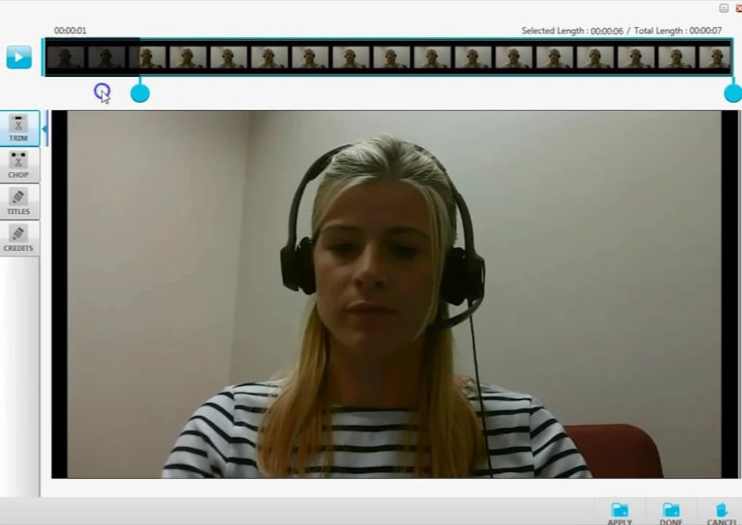
Wilmington University Educational Technology
- You can use Trim to cut out a segment from your video, and Crop to cut out time at the beginning and/or end. Click Apply to save your changes.

Screen Recording or Screen and Webcam Recording

  - If you choose Screen, you will be asked if you want to capture your whole screen, or you will be given the choice to select an area of your screen to capture. You can drag your mouse over the area you want to be seen in your video. Once you choose one of these options, you will be given 5 seconds and your recording will start.

  - If you choose Screen & Webcam, you will get the same option as if you choose Screen and once you choose either full screen or the section of your screen to record, you will be given 5 seconds. Then, CaptureSpace will begin recording your screen and your webcam simultaneously, using the devices you selected in your settings.

Presentations and Lectures

  - The most dynamic tool offered by CaptureSpace is the Presentations & Lectures tool. If you choose this button, you will be given a preview of what you are about to record.
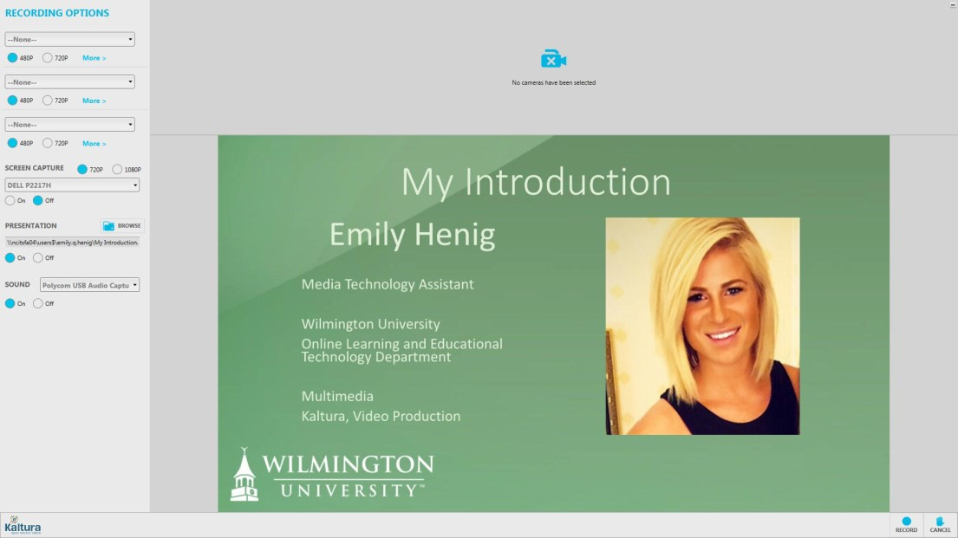
Wilmington University Educational Technology

- Here, you can choose to include your webcam or not, and you also have the option to include up to two additional camera inputs.

- Next, choose whether you want to record your screen or use a PowerPoint.

- Click Browse to import a saved PPT file.

5. Press record when ready and you will be given 5 seconds before your recording begins. Again, you can pause and resume, and later trim and chop.

When using the screen recorder or the presentations and lectures tool, you have a Draw tool available to you.
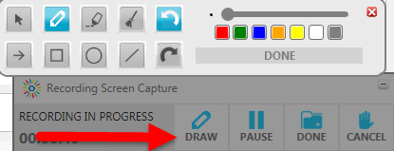
You can use this tool to write on your screen, highlight words, and draw arrows, squares, circles, and lines. You also can change the size and color of what you are drawing, and the tool allows you to clear everything, or undo and redo.

When you have finished your recording, made any changes, and clicked Apply if necessary, click Done and you will be asked to give your video a Title, Description, and Tags, all of which are important for identifying and later locating your video. Clicking Save saves your changes and stores your file locally. Be sure to click Upload to save your video to your Kaltura “My Media” storage in Blackboard.

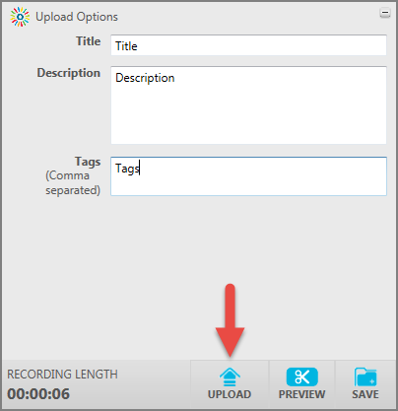
Wilmington University Educational Technology

You can now go back to Blackboard, go into your My Media, and find the new media you created using CaptureSpace.

Course Level Interaction
Uploading media at the course level automatically associates that media with the course. All items created at the course level will also appear in your institution level My Media gallery. (Remember that adding to the Faculty Repository has to be done from the institution level.)

The Media Gallery tool is not added to the course menu by default. You can easily add it to the course menu if you want the course level media gallery to appear in the course menu by pressing the + button at the top of the course menu and selecting Tool Link.

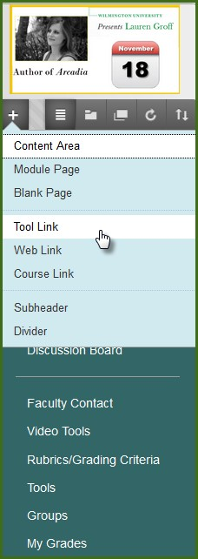
Wilmington University Educational Technology

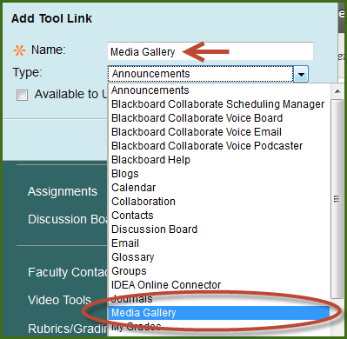

Select Media Gallery from the drop down list and give the tool link a name (Media Gallery is a good one, but you can name it whatever you like). You do NOT have to add the Media Gallery to a course for the course Mashup tools to work, but if you deploy a video from the Faculty Repository or your institution level Media Gallery you may want to have the item in your course menu for easy organization.
After you add the Media Gallery it is hidden by default, and all media uploaded or published to the Media Gallery is also hidden by default, so if you want students to see the videos in the course gallery you will need to show both the tool and the videos.
Wilmington University Educational Technology

Adding content via the course Media Gallery
If you want to add or create media to a particular course but want to assign it to specific content areas later or just have a collection of media associated with that course you can use the course Media Gallery. (You’ll need to add the tool link to the course menu first.) Note that the Media Gallery in the course menu is hidden from student view by default.

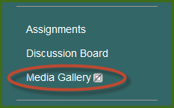

Upload
In your course media gallery the Add Media button is at the top right, and the list of any media you’ve added or created in the course gallery is below it. You can publish videos here from your own My Media or from a shared repository like the Faculty Repository. You can also view analytics for media that you’ve shared to your course by pressing the Analytics button under the Actions menu.

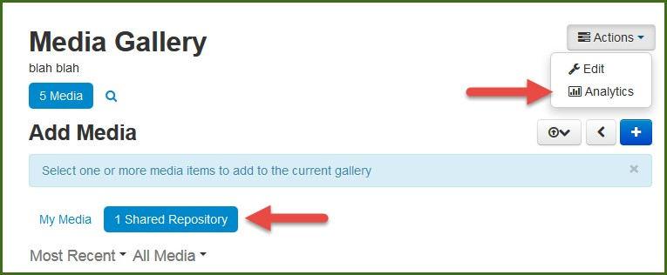

Uploading a video file to the Course Gallery works in exactly the same way as uploading to your My Media gallery at the institution level, so you can follow the same steps. Note that videos uploaded to the course gallery will be associated automatically with that course. To deploy them to another course or add them to the Faculty Repository you will have to visit the My Media gallery at the institution level.

Adding video content via Mashups

    - Under the Build Content tab there is now a mashup tool for Kaltura Media.

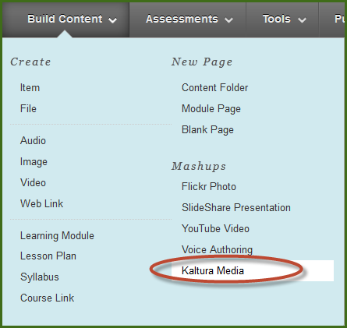
Wilmington University Educational Technology

Here you will be able to insert media from your own My Media gallery, from the Faculty Repository, or from videos you’ve shared to the Media Gallery in the course. You can also search any gallery via metadata and tags, or create new media with the Add New button in the top right.
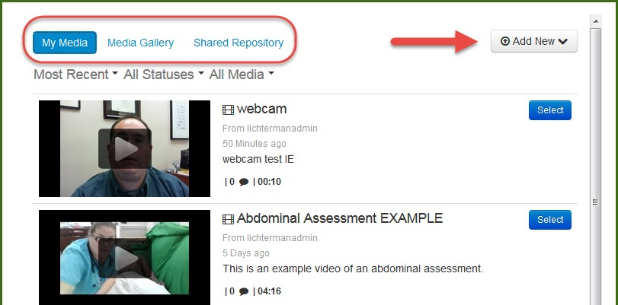
You can preview the videos by clicking on the thumbnails. Select existing media by clicking the blue buttons next to the thumbnails.
After selecting a clip you will be taken to a standard Blackboard item creation screen. There you can give the item a title and add any instructions or other materials you need to incorporate the video into your course.

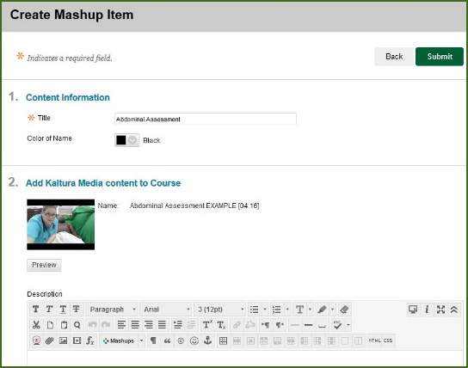

Wilmington University Educational Technology

After you press the Submit button you can organize or edit the item just like any other content item.
You can also upload or create media using the Add New button at the top right. Adding media via a mashup adds it to that content area only. It does not add it to the course gallery and you cannot add it to the Faculty Repository. However all media created by you in Blackboard will appear in your institution level My Media, and can be deployed to a course gallery or to the Faculty Repository from there.

Using a Mashup from the WYSIWYG toolbar in any content item

You can add or create media as a mashup anywhere in Blackboard where the WYSIWYG toolbar appears. This includes assignments, assessment questions, discussion boards, announcements, and more.

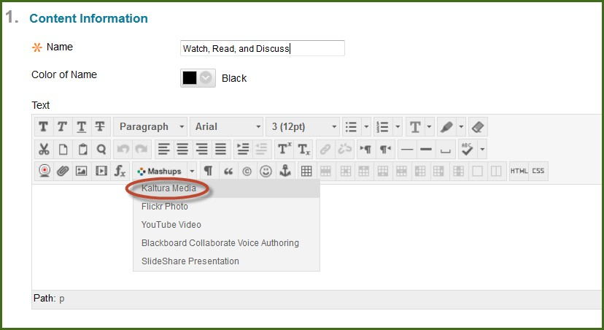

Inserting into a content item using the WYSIWIG toolbar gives you all the same tools as with all Kaltura media. You can upload or create content from within the content item with the Add New button or search and select from your media, the media gallery, or the Faculty Repository.

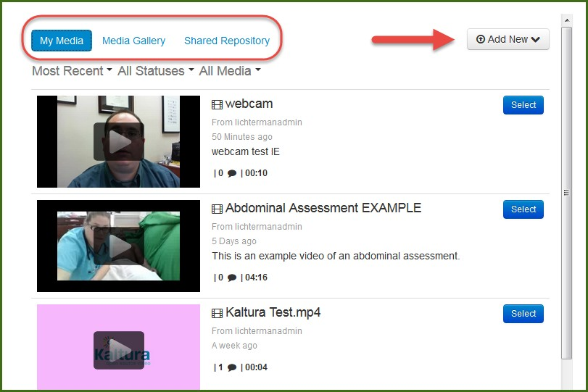
Wilmington University Educational Technology

This allows you to add or create media within a content item almost anywhere in Blackboard and add other text, images, links, etc. around it. This could be especially useful for discussion boards or assessments where you want to make a video a component of a larger assignment.

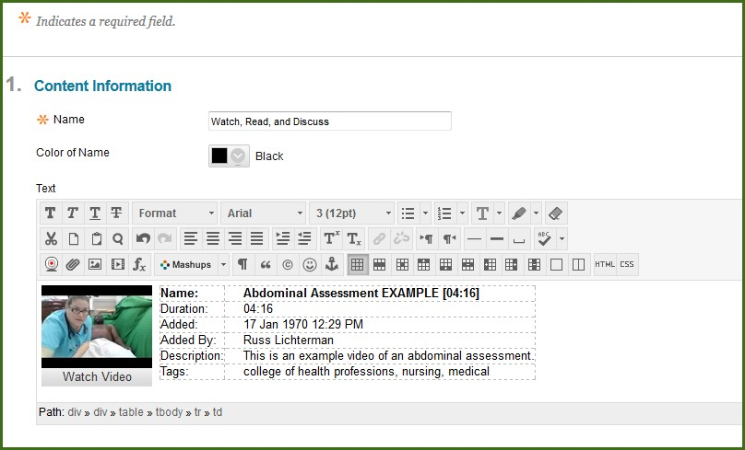

The difference between the Build Content mashup tool and the WYSIWIG toolbar mashup tool is that the WYSIWIG mashup creates a Kaltura media item inside another Blackboard content item, while the Build Content mashup creates a stand- alone media item in Blackboard.

What else can it do?
Using rich media content in your courses and organizations is only limited by your imagination. There are many interesting ways to combine different tools and create dynamic content for students. Videos from smartphones and tablets can be used to bring real-world examples into the Blackboard environment, or screen recording could be used for narrating PowerPoint slides or demonstrating formulas with an on-screen scientific calculator.

Need more help? Reach out to multimedia@wilmu.edu with questions about Kaltura for Blackboard or to request training, or contact the WilmU Helpdesk for technical problems with Blackboard or hardware and software concerns.
Wilmington University Educational Technology
http://www.wilmu.edu/techres/emailtechsupport.aspx

