Creating a Prezi Education Account

1. https://prezi.com/pricing/edu/ Sign up for a free Prezi educator’s account. This option allows you to keep your Prezi’s private. If you already have a Prezi account, you may skip this step and login to Prezi to begin a presentation.
Click the Continue button on the “EDU Standard” version.
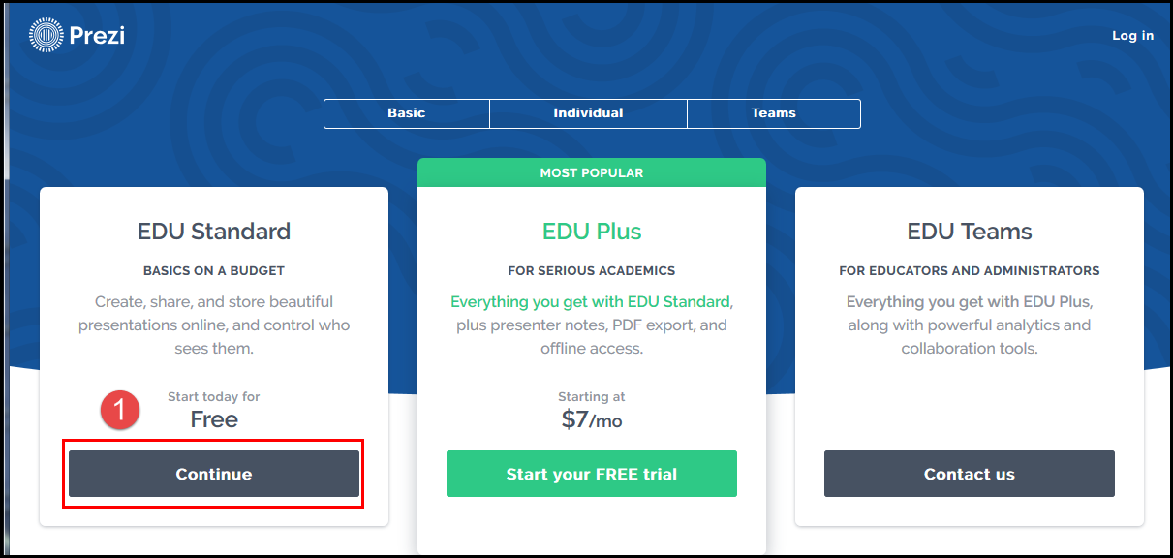

2. Type in your Wilmington University email address, then click the Verify button.
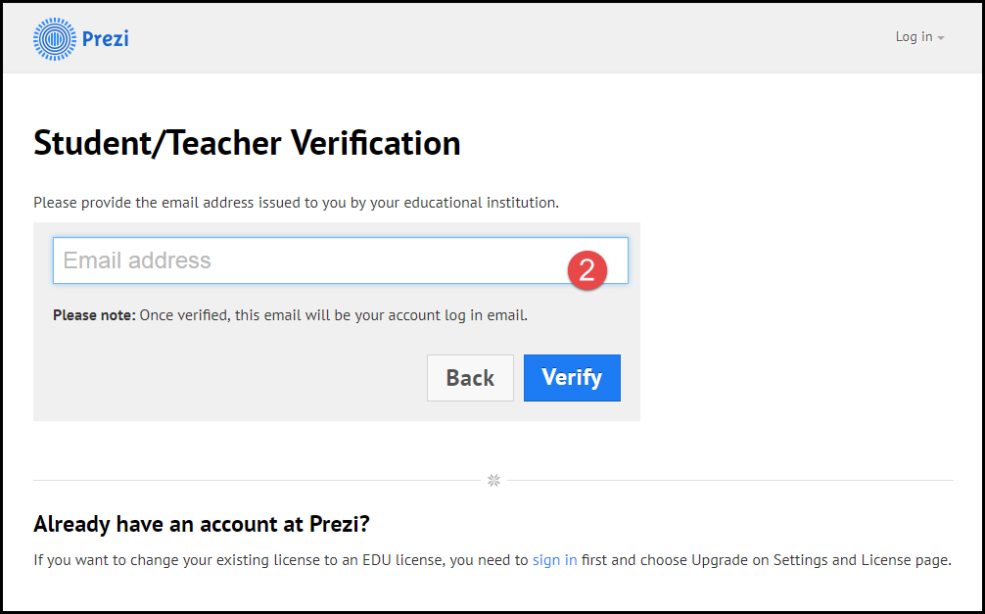
3. Fill in University Details. Please click the checkbox to confirm. Click Continue.
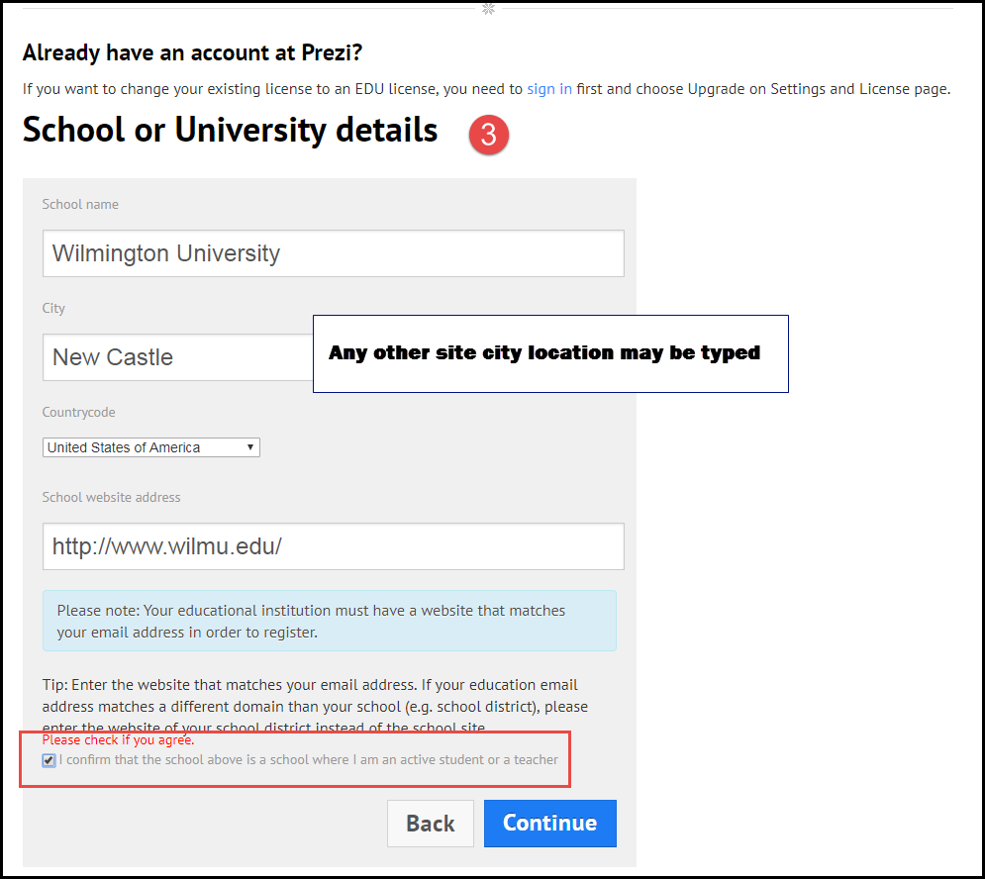

4. A dialogue window opens to let you know a confirmation email has been sent to you. Go to your WilmU email and click the link to complete the registration. 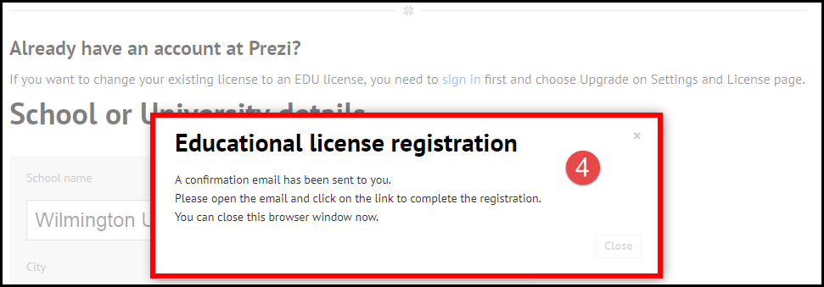

5. (*You may find the Prezi activation email in your Junk email folder.)
Open the Prezi email and click the link to activate.
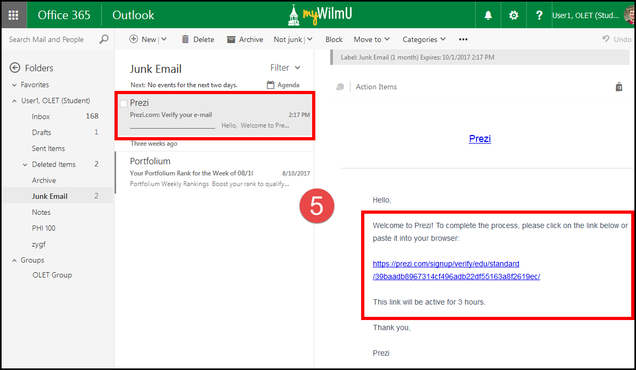

6. The Account Creation Page opens. Fill in First and Last name, email address. Create your own password with 8 or more characters. Then check the reCaptcha box to declare you are not a robot. Click the button “Create your free Edu Standard account.”
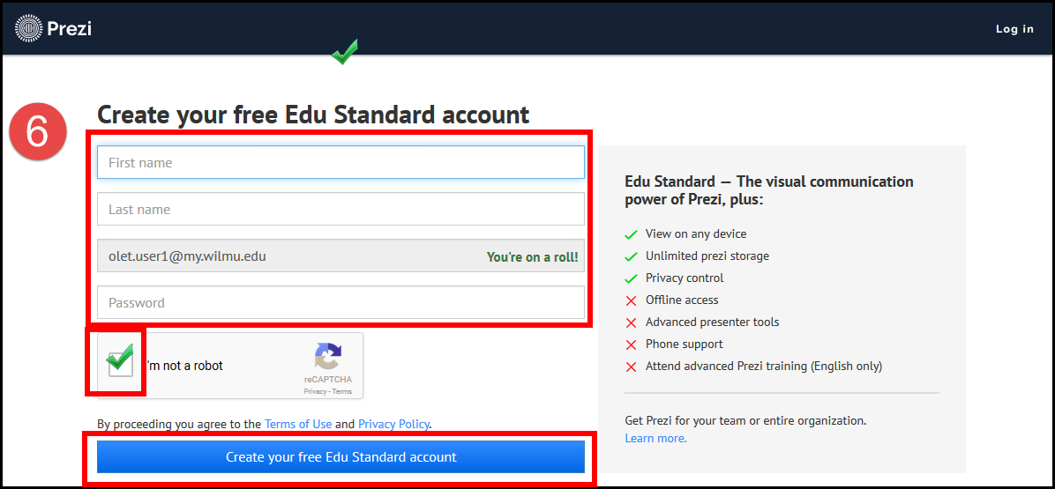
7. Your account will be created, and you will be launched to Prezi. Click the appropriate button on the about you page. Click Next.
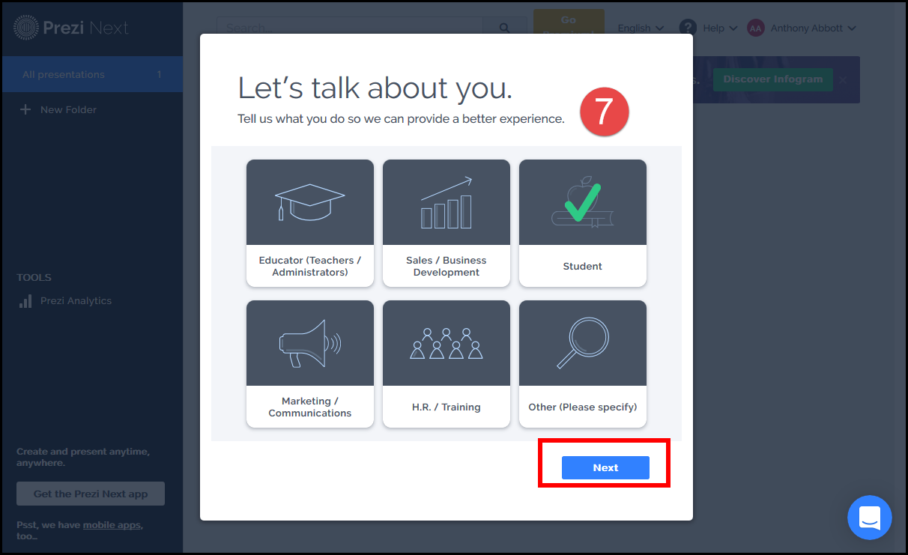
8. You may get a window that says your browser does not support Prezi. If you get this message, please login into Prezi with Chrome. The browser types supported are Chrome, Firefox 64 bit, and Safari 10. If using a phone or tablet, the mobile devices do not support editing and creating Prezis.
