Active Learning
This learning opportunity will help instructors learn how to keep students engaged and excited about course learning content through the inclusion of active learning techniques. At the conclusion of this session, faculty will be able to:
Objectives | - Define active learning and identify various active learning techniques.  - Explain the impact active learning exercises has on student learning outcomes.  - Convert existing class agendas to incorporate effective active learning strategies.
Assessments | Proficient level= course relevant application

Resources

What is active learning?
Active learning techniques engage students in the learning process by requiring something more than passively listening. Simply put, when we as faculty are lecturing to students we are asking them to engage in passive listening. All other instructional techniques employ active learning in one form or another. Active learning can be applied to classroom activities at any level of student understanding, from analysis through synthesis of and application of class learning content.
  - The web article outlines what active learning is in more detail and why we should consider these activities while teaching from the student learner perspective.

What are some common active learning techniques?
Due to the potentially limitless list of different options to explore it is not our intent to be comprehensive here. By reviewing the below we can begin to understand the logic that there are different types of active learning situations and that appropriate alignment of a selected activity and desired student learning outcome should be pursued. For the greatest impact we might divide the categories of techniques described in a manner that matches Bloom’s taxonomy of student learning. For example:
- Providing students with meta-cognitive reflection opportunities- such as the one-minute paper, the muddiest point, structured questions and answers, etc. (Remembering)
- Providing students with a different avenue for acquiring and applying course content- such as the gallery walk, peer teaching activities, application exercises, etc. (Understanding)
- Providing students with an authentic application of course content-such as the case study, debate, mock trial, role playing, etc. (Applying and Analyzing)
- Providing students with the opportunity to collaborate- such as the jigsaw classroom, or think-pair-share exercises, concept maps or sketches, etc. (Evaluating)
- Providing students with a puzzle or problem to solve with no clear solution-such as problem-based learning, group projects, etc. (Creating)

Most active learning techniques can also be group based on the learning mechanics associated with the activity- those aimed to give students time to review on their own, those that ask students to review collaboratively, and those that ask students to create or to solve novel situations or puzzles on their own. The following resources can be used to help you develop some course relevant active learning activities:
  - Think-pair-share: A structured approach to class discussions
  - The jigsaw approach: Have students work collaboratively to build learning experiences
  - Just-in-time teaching: A means of using pre-class time to determine where to focus in-class review of course content
    - For additional information on this technique, please review this article
  - A list of common active learning examples
  - List of common active learning techniques grouped by the type of activity

Our goal as faculty should be to identify different techniques and develop an approach for proper pairing of selected technique with student learning goal for a given class meeting.

What impact does active learning have on student learning outcomes?
Here we address the why associated with active learning. Research indicates that student retention of information is very low for passively learning opportunities as compared to active learning techniques, as illustrated by the Learning Pyramid chart below.
As faculty we should strive to provide students with a classroom environment that matches how information will be used in the professional setting. The more authentic our active learning exercises, the higher level of student retention of course related learning material.
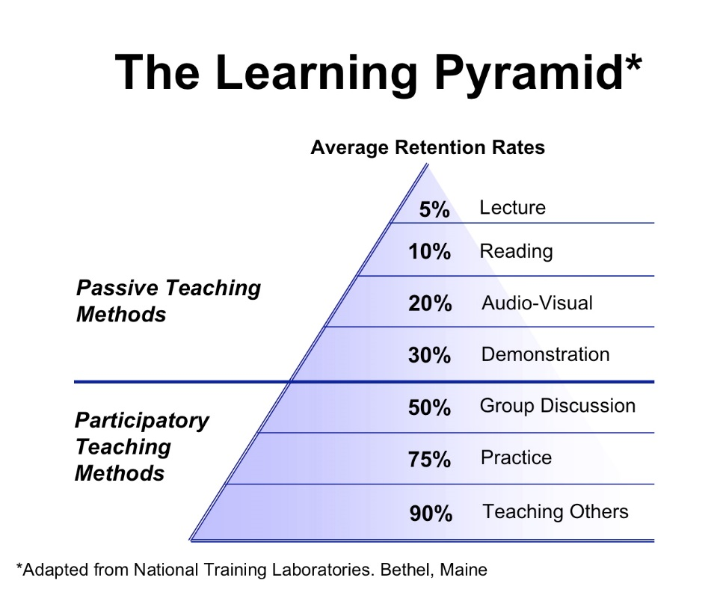

How should I approach adding active learning exercises to my class agenda?
For this module we encourage faculty to take a look at an upcoming class agenda, and try to convert a planned passive experience into one of the active learning situations detailed above.
If you would like to discuss this topic, or to forward your planned activity to the CTE for feedback please feel free to send us an email at facultydevelopment@wilmu.edu.

How do I earn credit for this session on my Pathway to Instructional Excellence?
Our active learning module is designated as a CTE (Center for Teaching Excellence) Proficient Level Elective. At this level, the CTE is looking to see faculty application of active learning techniques to a class agenda for an upcoming class session. Please upload a document into your WilmU Learning Center profile that outlines your planned class agenda that incorporates active learning exercises and predicts how these efforts will impact student learning. Please include the following in your submission:
- The intended class learning outcomes or objectives you plan to address
- The active learning exercises you have selected for this class session
- The predicted impact these instructional activities will have on student learning for this class meeting
Faculty submissions will be scored using the Proficient Level Rubric. To earn completion of this exercise, faculty must score 4/5 or higher. Faculty scoring 3 or lower will receive feedback from the CTE and will have the opportunity to resubmit their active learning techniques application.

CTE-Pathways to Instructional Excellence-Proficient Level Rubric
Scoring= 1  Unrelated | 2  Beginner | 3  Essential | 4  Proficient | 5  Mastery
Submission appears unrelated to learning unit. Evidence of teaching skill not present in faculty submission. | Submission shows ability to recall correct terms but lacks ability to apply learning content to described teaching situation. | Submission shows understanding of how to apply learning content to teaching situation but lacks ability to anticipate the impact this decision will have on student learning. | Submission demonstrates correct application of teaching skill and correctly identifies potential impact this will have on student learning. | Submission demonstrates correct application of teaching skill, identifies potential impact on student learning and ability to tailor teaching to individual student needs.

