Before Getting Started
To ensure you are ready to use Respondus LockDown Browser, you must meet the following requirements before you begin:
-A local admin account is required to run the program. Most likely it will be the same account you used for the installation process.
-As part of the monitoring, a webcam and microphone are required.
-These will be tested during the initial check before you begin the test/quiz.
-You may use a built-in webcam/microphone if your computer has that already, or you may connect a webcam and microphone to your computer to use.
-As part of the ID verification, you will need to take a picture of your photo ID.
-You may use your Wilmington University student ID, driver’s license, or other legal form of photo ID.

Step 1- Navigate to the quiz through your standard web browser, such as Google Chrome or Mozilla Firefox
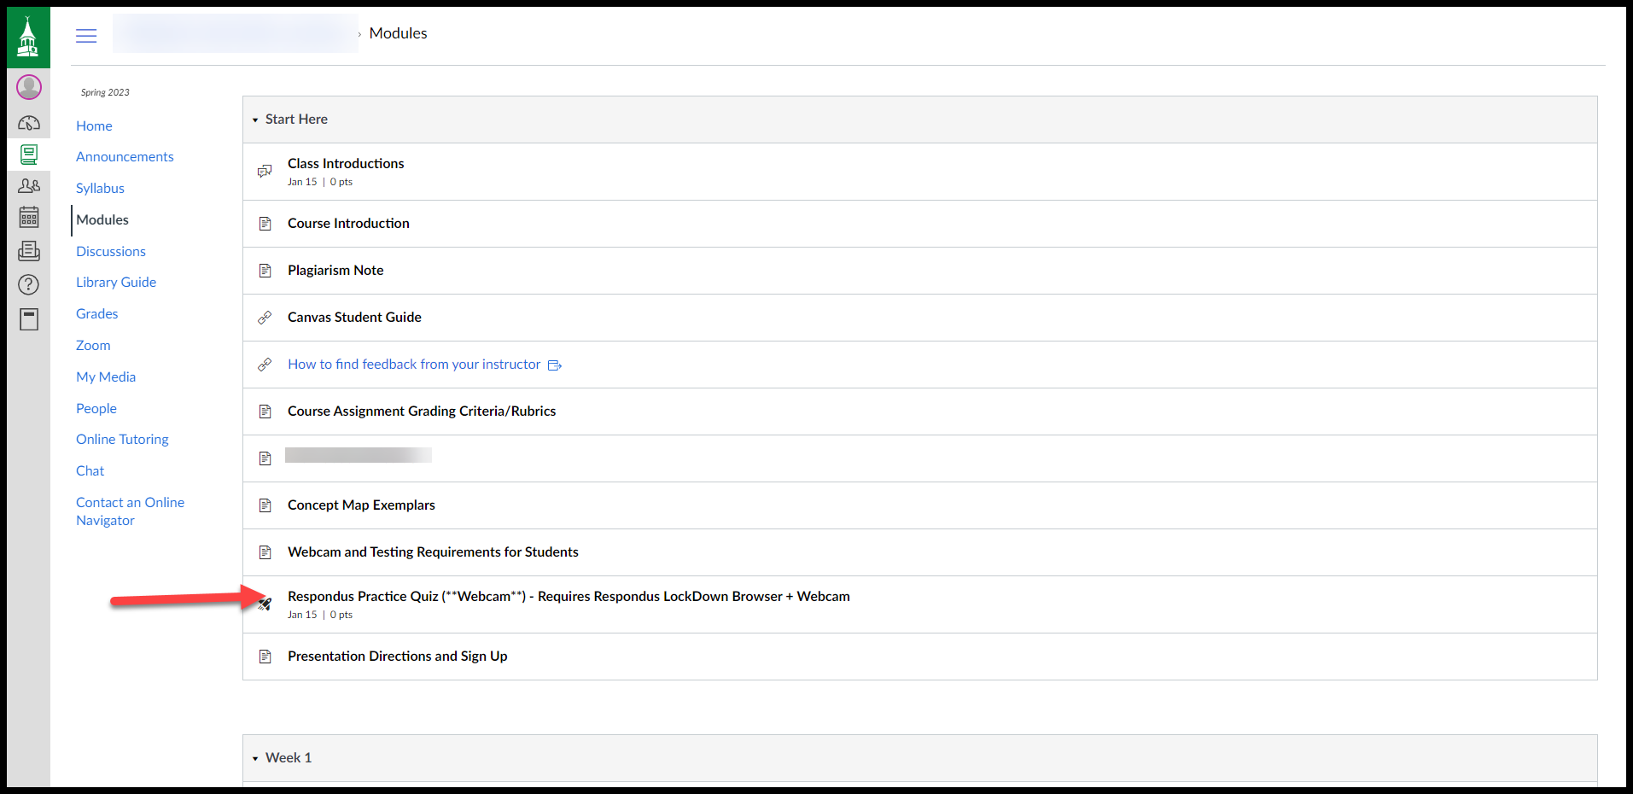
If you have not installed LockDown Browser, you will be given the option to download it now, by clicking “Download and install LockDown Browser to this device”. Alternatively, you can use the following link- https://www.respondus.com/lockdown/download.php?id=575414501
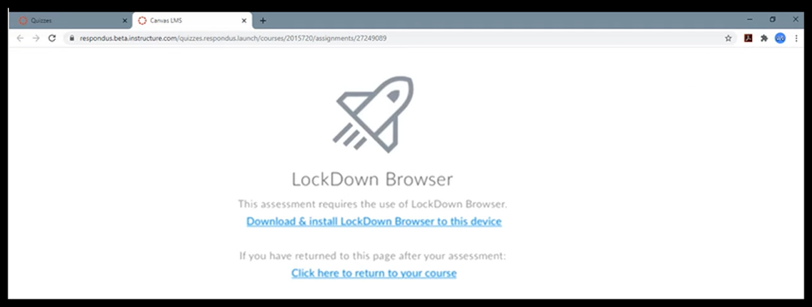
Admin Approval to Run the App
Depending on your permissions, you may have to enter administrator credentials to install LockDown Browser
Option 1 (Signed in as a local admin):
- Click “Yes” to approve running the app.
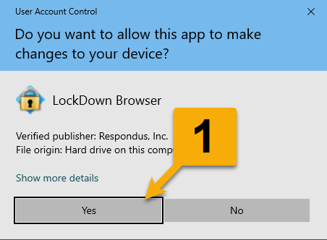
Option 2 (Not signed in as a local admin):
- Enter the user name of the local admin.
- Enter the password of the local admin.
- Click “Yes” to approve running the app.
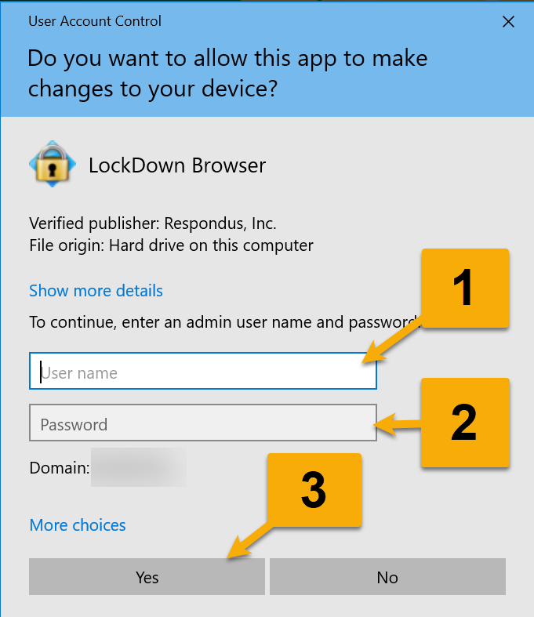
Once you have installed and run LockDown browser, you can navigate back to the quiz in your standard web browser.
If your computer detects that LockDown Browser is installed, you will see the following screen-
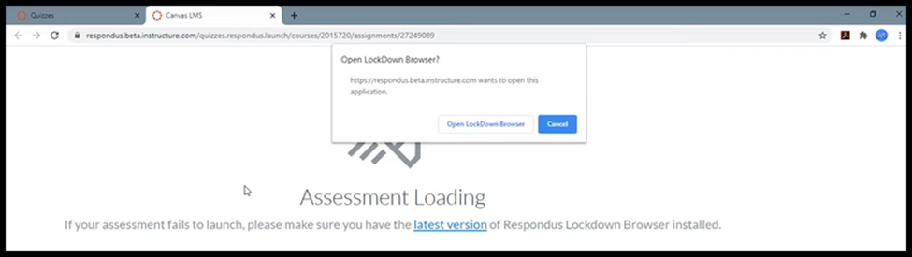
From here, clicking “Open LockDown Browser” will launch the application
Close Unapproved Processes/Applications
When you first open Respondus LockDown Browser, it will provide pop-up alerts for each of the processes/applications that must be closed. These must be closed to continue as they are not permitted to run while using LockDown Browser.

- For most alerts, you will just need to click “Close Process.”
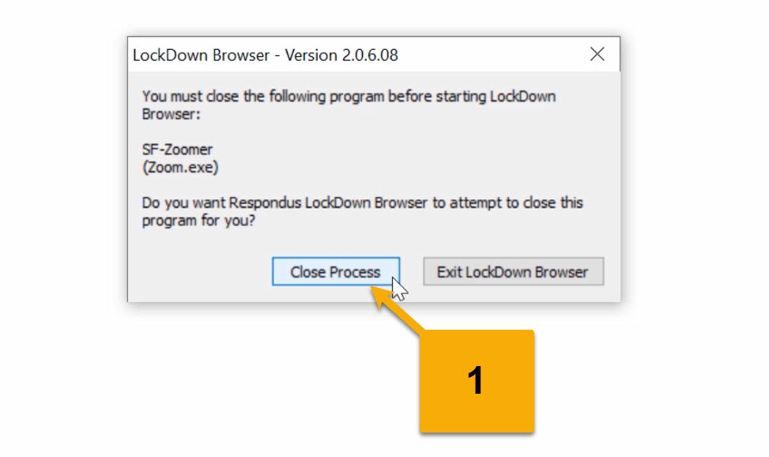

- In some cases, you will get a warning to exit LockDown Browser so you can safely close the program yourself. For this example, we are going to click “Exit LockDown Browser” so we can close Outlook ourselves.
  - Check to see if there is anything you need to save in Outlook before closing it.
  - Right-click the Outlook icon in the task bar.
  - Click “Close Window” and then you can open LockDown Browser again.
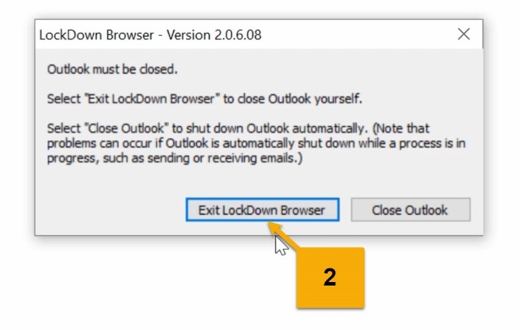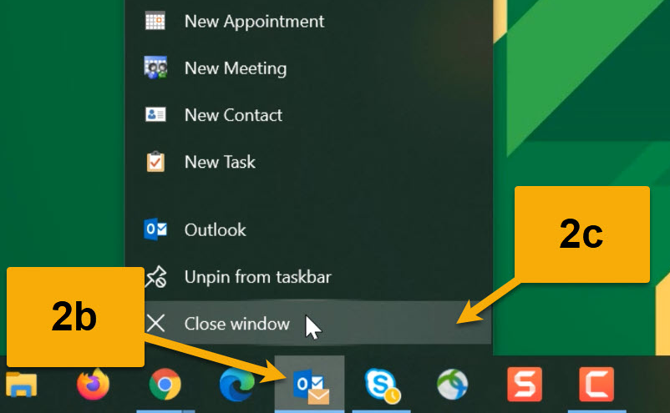
Close Unapproved Processes/Applications (continued)
- Other times, you may get a warning for a program you must close that LockDown Browser is unable to close itself.
  - Click “Ok.”
  - This will close LockDown Browser.
  - Close the application that the message said and then you can open LockDown Browser again.
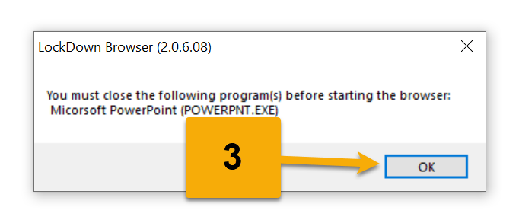

- If you still get warnings of programs to close that you don’t see open, check the Task Manager and close them from there.
  - Press the keys [Ctrl] + [Shift] + [Esc] (Windows) or [CMD] + [ALT] + [ESC] (Mac).
  - Find the program you need to close and click on it.
  - Then click “End Task” (Windows) or “Force Quit” (Mac).
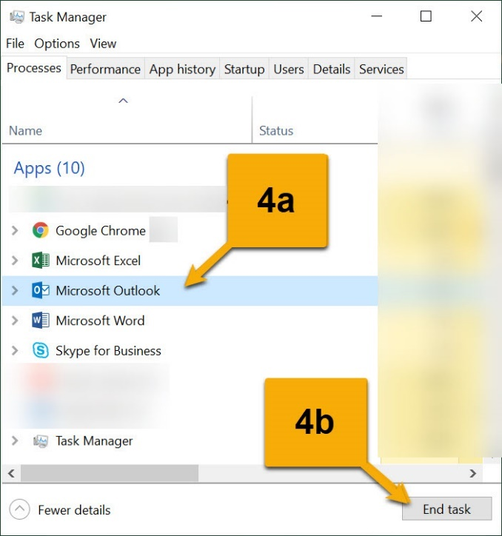
Once the unapproved processes and applications are closed, you will be able to proceed further when you open LockDown Browser.
Terms of Use
- Read the Terms of Use.
- When finished, click “Agree.”
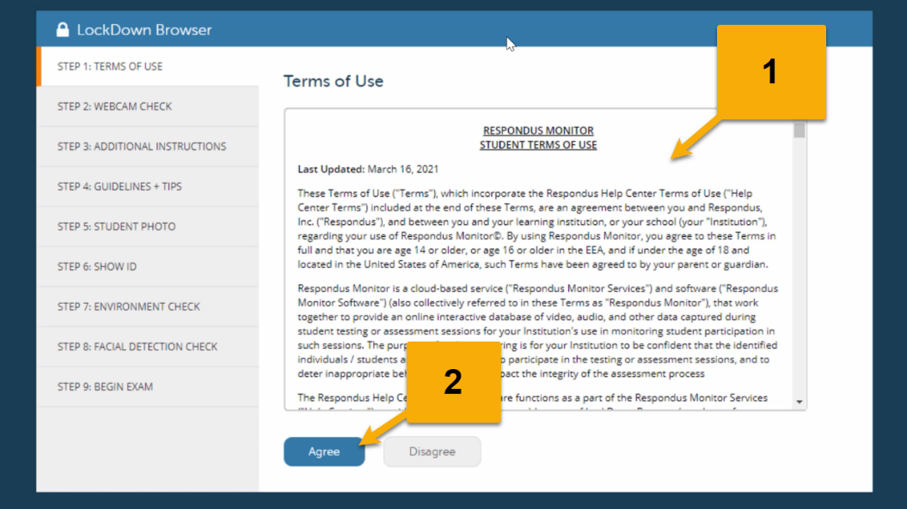

Webcam Check
- You want to make sure you see a preview of your webcam.
  - If you have multiple webcams connected, you may need to click “Change my webcam.”
- Once you see yourself in the webcam preview, click “Yes.”
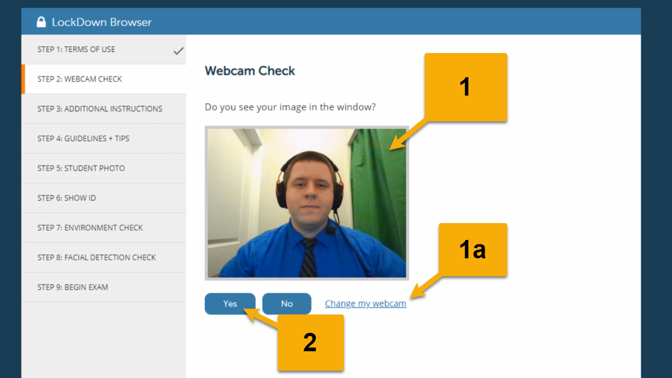
*If you still don’t see your webcam preview, trying closing Respondus LockDown Browser and make sure your webcam is fully connected. You may want to test it in another application and/or try restarting your computer.
Webcam Recording Check
You are now going to test your video and audio by recording your webcam. During the recording you will need to be speaking. You could say the alphabet, count, or talk about something else.
- When you are ready, click “Record Five Second Video.”
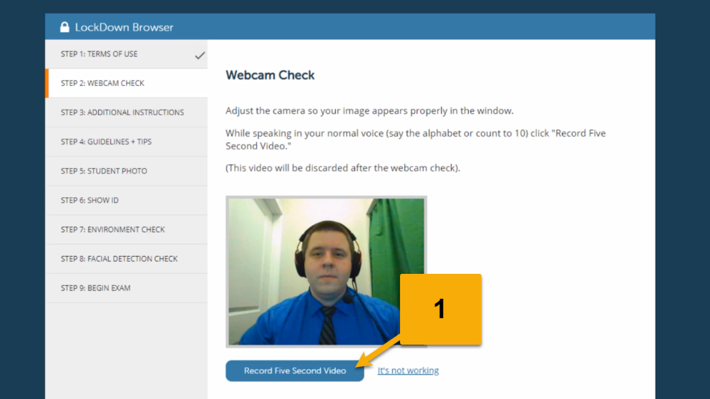

Webcam Recording Review
- Watch and listen to the recording.
  - If you can’t see or hear yourself, click “Try Again” to start over.
- When you can see the video and hear audio, click “Continue.”
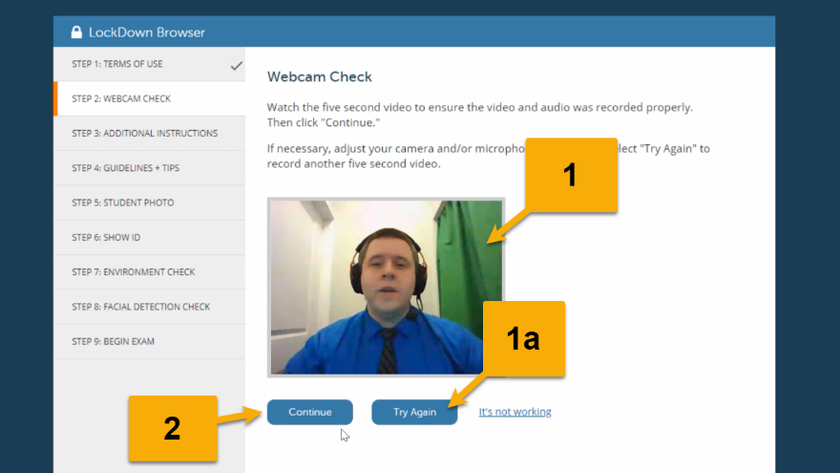
*If you are still experiencing issues with your audio, you should exit Respondus LockDown Browser. Check to make sure your microphone is fully plugged in and enabled. Try testing your microphone with another application and/or try restarting your computer.
Additional Instructions
- Read the additional instructions that may be included at this point.
- Click “Continue” when you are finished.
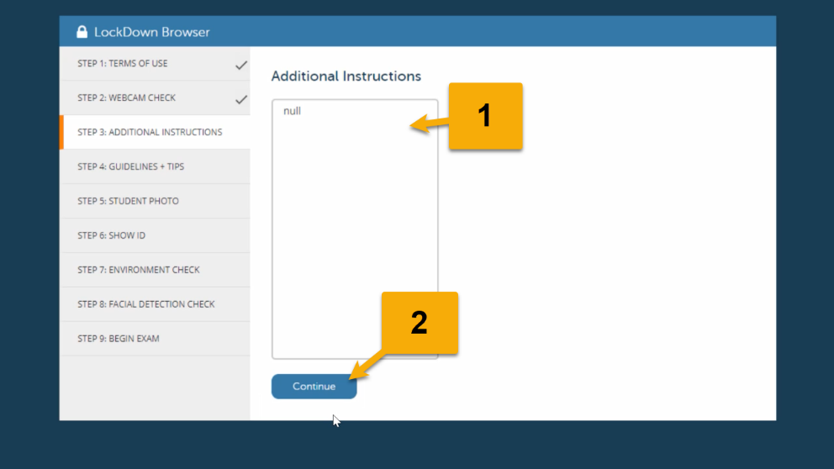

Tip 1
- Select a quiet location where you won’t be interrupted or distracted.
- Click “Next.”
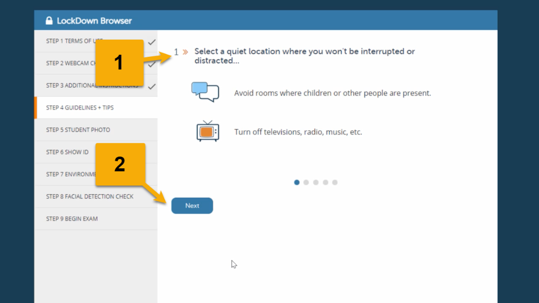

Tip 2
- Make sure your internet connection is consistent and strong.
  - Use a wired internet connection, if possible.
  - If you are on a shared network, ask others not to stream videos or play video games online while you are taking the quiz/test.
- Click “Next.”
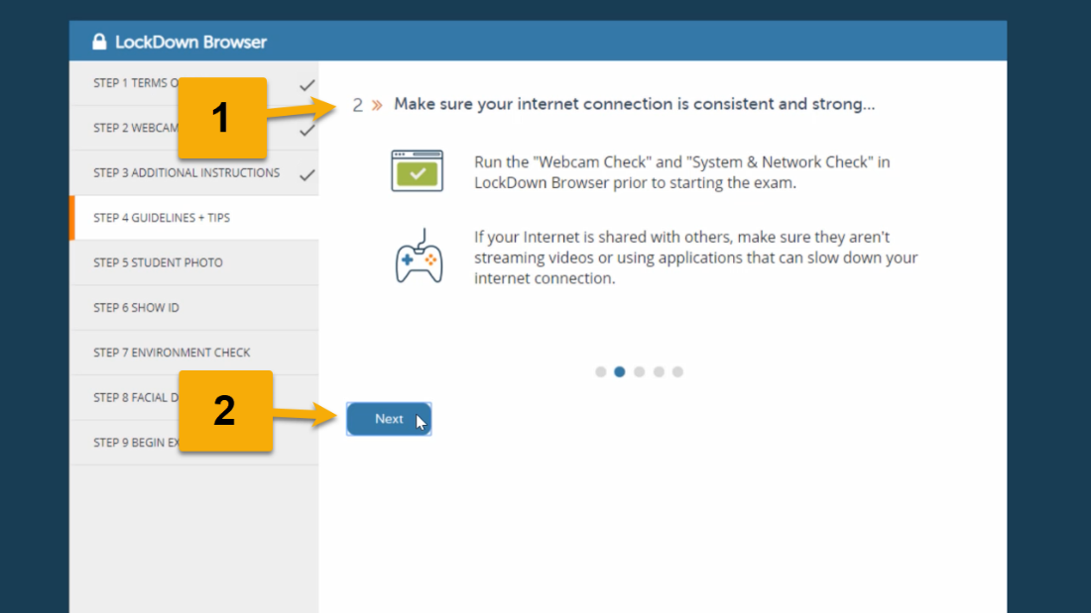

Tip 3
- Place your computer or device on a flat, hard surface such as a table or desk, and sit in a chair during the exam.
- Click “Next.”
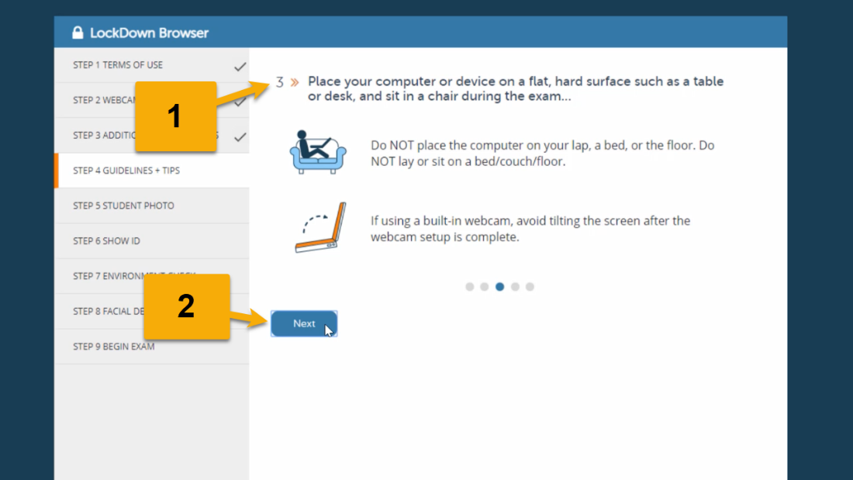
Tip 4
- To improve the quality of your webcam video (and reduce flags), avoid wearing anything that may cover your face (sunglasses or hats with brims) and make sure you are in a well-lit area.
- Click “Next.”
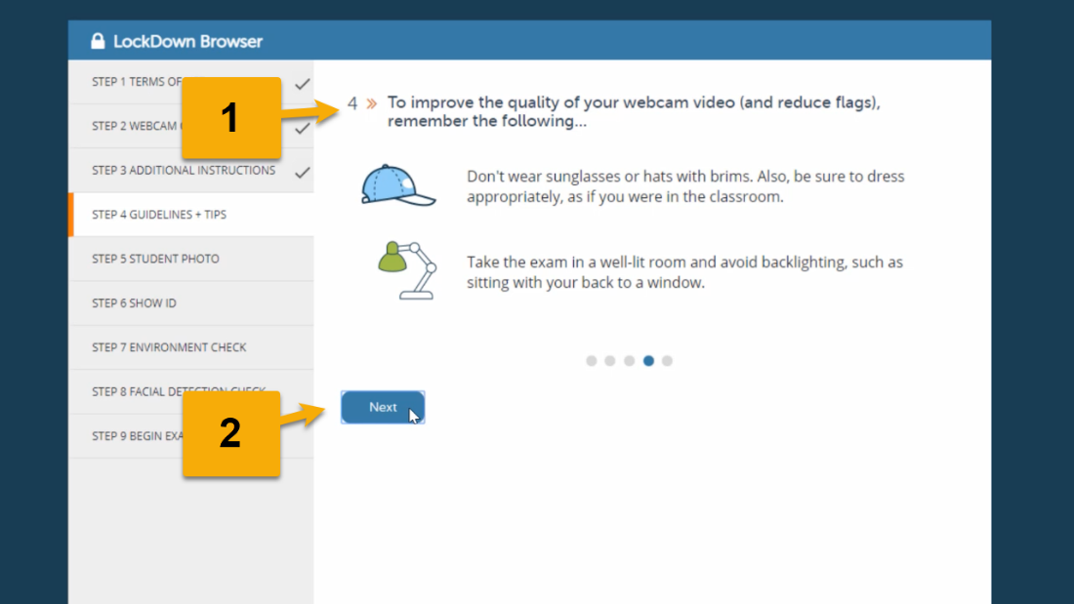

Tip 5
- Other things to remember:
  - Keep unauthorized items away from you during the quiz/test, like your phone.
  - You won’t be able to access other websites or applications during the quiz/test.
- Click “Continue.”
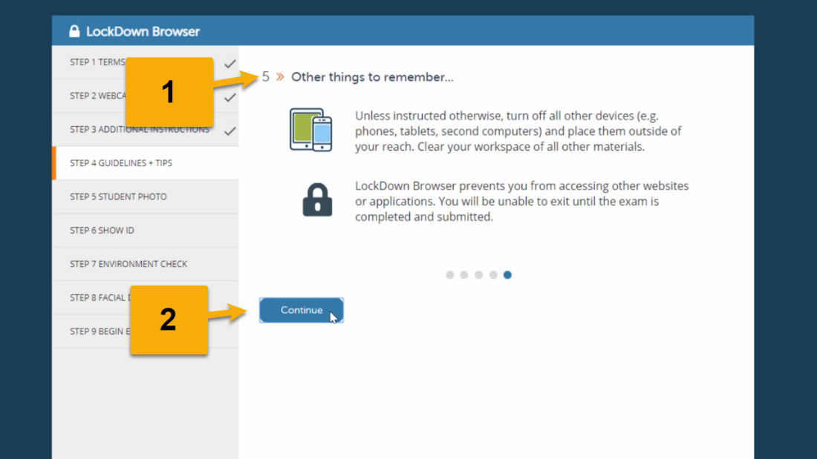
Student Photo
- Position your face close to the webcam so it fills the majority of the screen and is clearly visible.
- Click “Take Picture.”
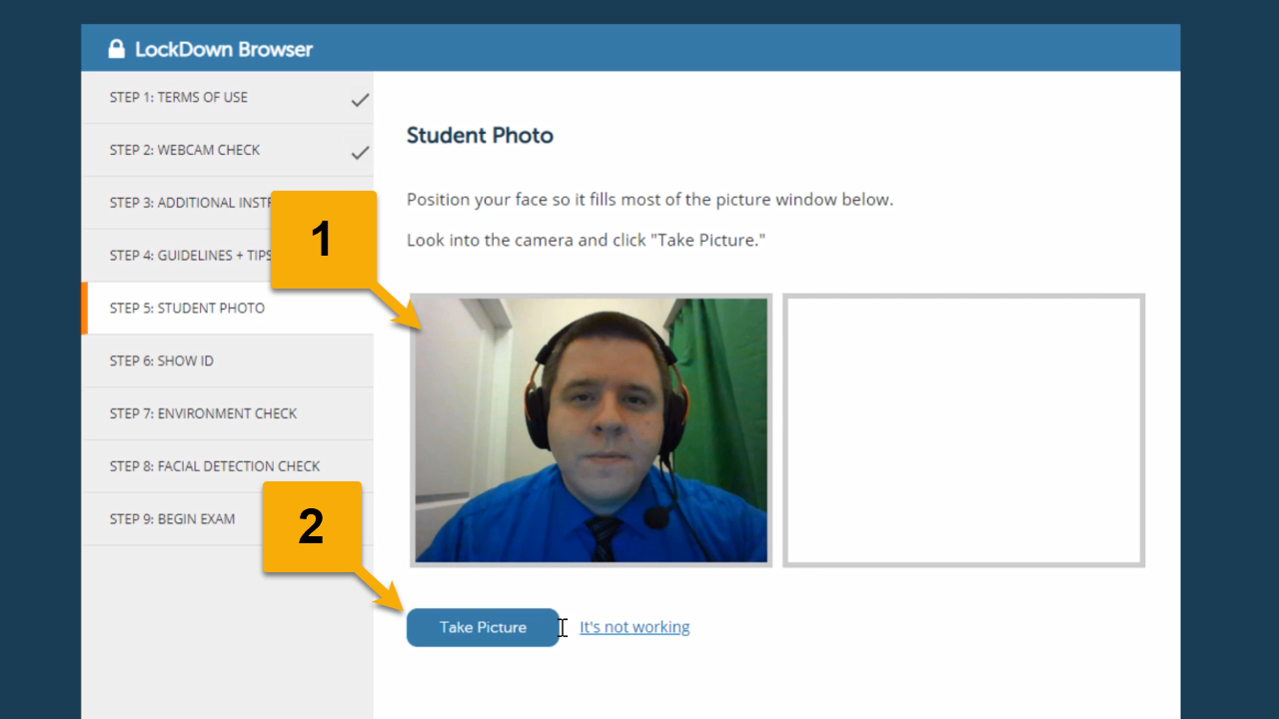

Review Student Photo
- Make sure your face is clearly visible in the picture.
  - If you need to take another picture, click “Try Again.”
- When you have a good picture, click “Continue.”
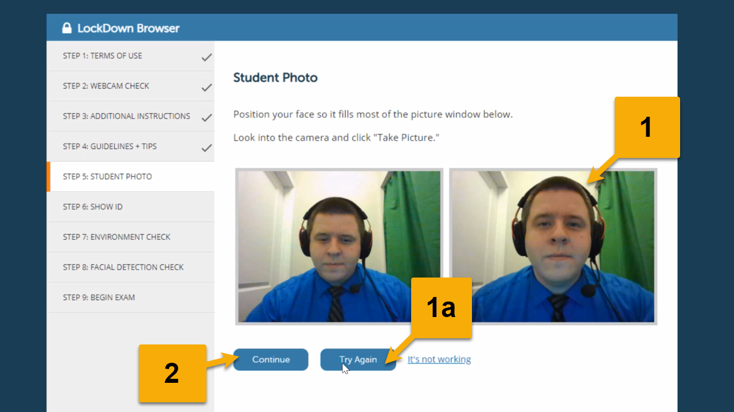

Photo ID
- Hold your photo ID up to the webcam so your name and picture are clearly visible.
  - Acceptable forms of photo ID include Wilmington University student ID, driver’s license, or other legal form of photo ID.
- Click “Take Picture.”
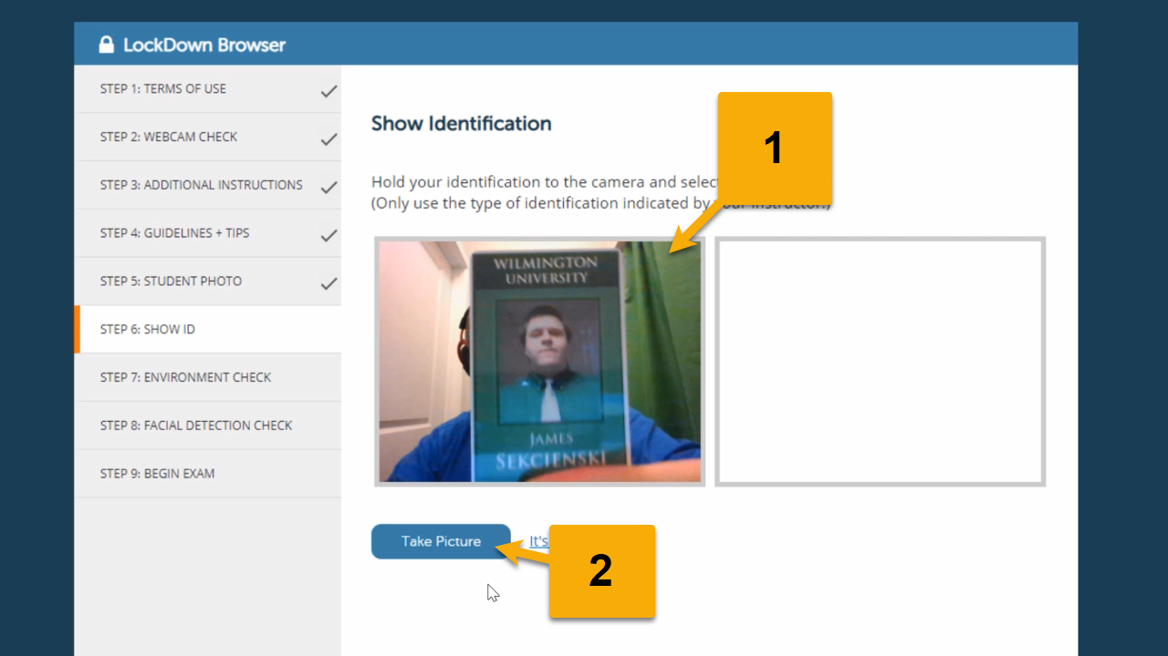

Review Photo ID
- Make sure your face and name on your ID is clearly visible in the picture.
  - If you need to take another picture, click “Try Again.”
- When you have a good picture, click “Continue.”
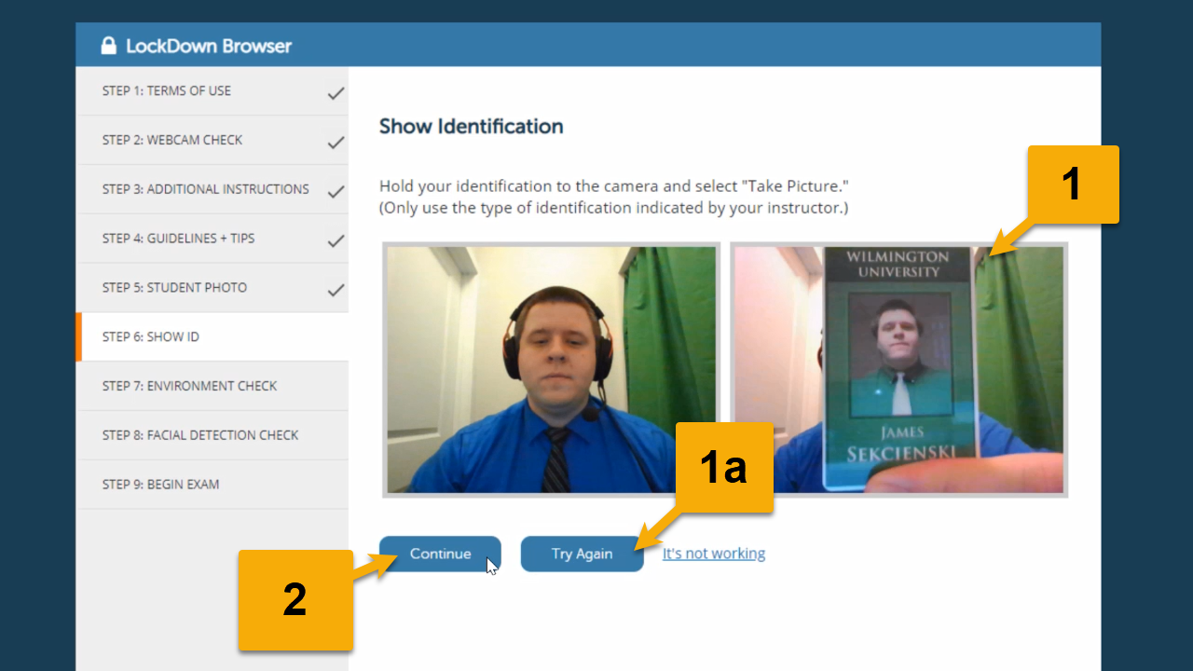
Environment Check
Make sure you don’t have any unauthorized materials around you and that your workspace is ready for testing. If your instructor approved any additional materials you may use during the quiz/test, be sure to have them with you now.
- When you are ready, click “Start Recording.”
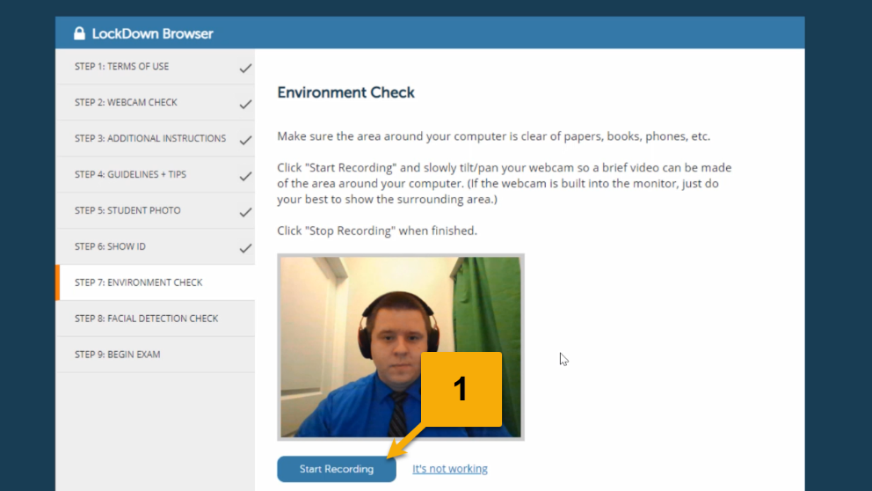

Recording Environment
- Move your webcam or computer (if the webcam is built-in) around your workspace to record the area where you are testing.
  - If your instructor approved any additional materials, be sure to hold them up to the camera to show what you are using during the quiz/test.
- When you have finished recording the area around you where you are testing, click “Stop Recording.”
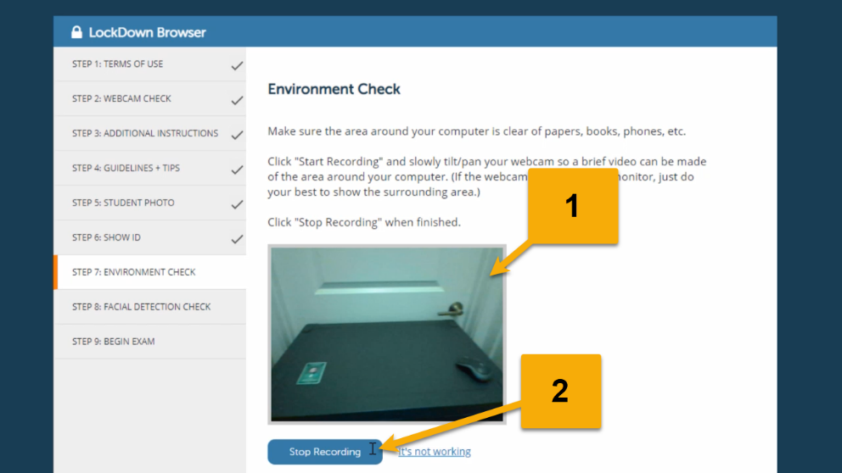
Review Environment Recording
- Watch the recording of your testing environment.
  - If you need to start over, click “Try Again.”
- When you have a clear recording of your testing area and instructor approved materials (if applicable), click “Continue.”
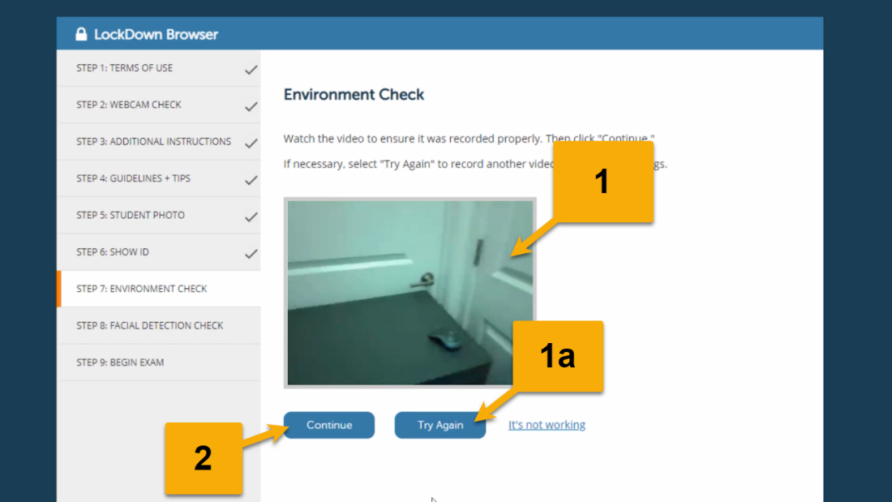

Facial Detection Check
- Adjust the webcam and lighting as needed until you get a green thumbs up for success.
  - You should position yourself the way you plan to be seated during the quiz/test.
- Click “Continue.”
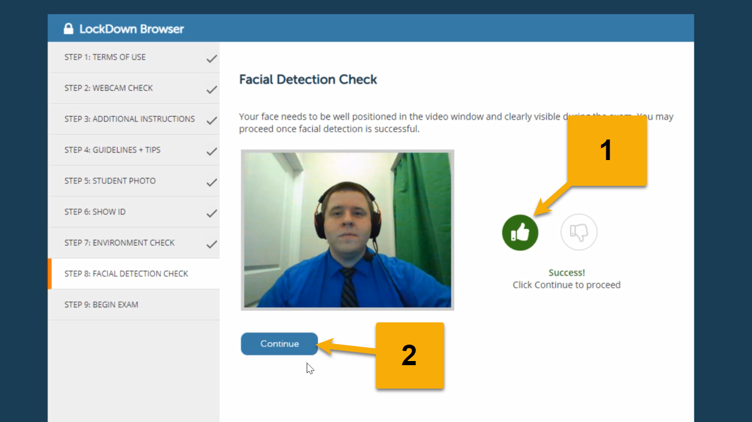
Begin Exam-
Once you have completed all of the necessary checks, you can select “Begin” to start the quiz
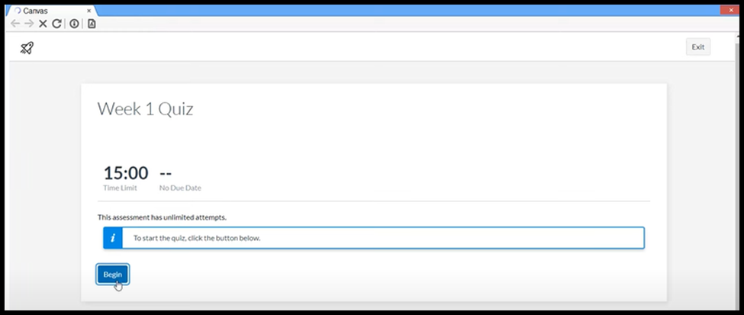

Submit Quiz-
When you have answered all the questions, you can click the blue “Submit” button at the top right corner.
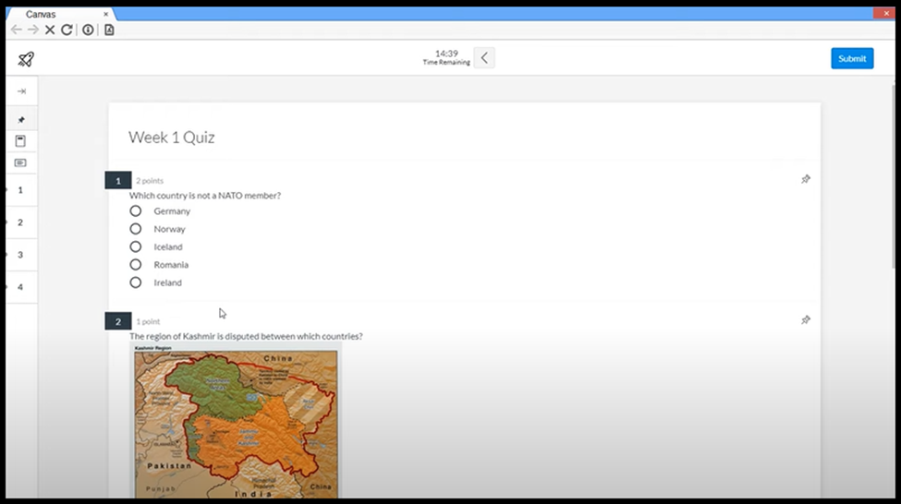

Feedback to Respondus
- Now that you have completed the exam, you will notice the recording icon is gone, indicating the recording has stopped.
- Select the option that best describes your experience during the exam.
- Provide any additional comments about your experience in the text area.
  - These are comments that are only seen by Respondus staff. Your instructor will not see these comments.
  - If you have questions or comments for your instructor, be sure to send them a message.
- Click “Submit.”
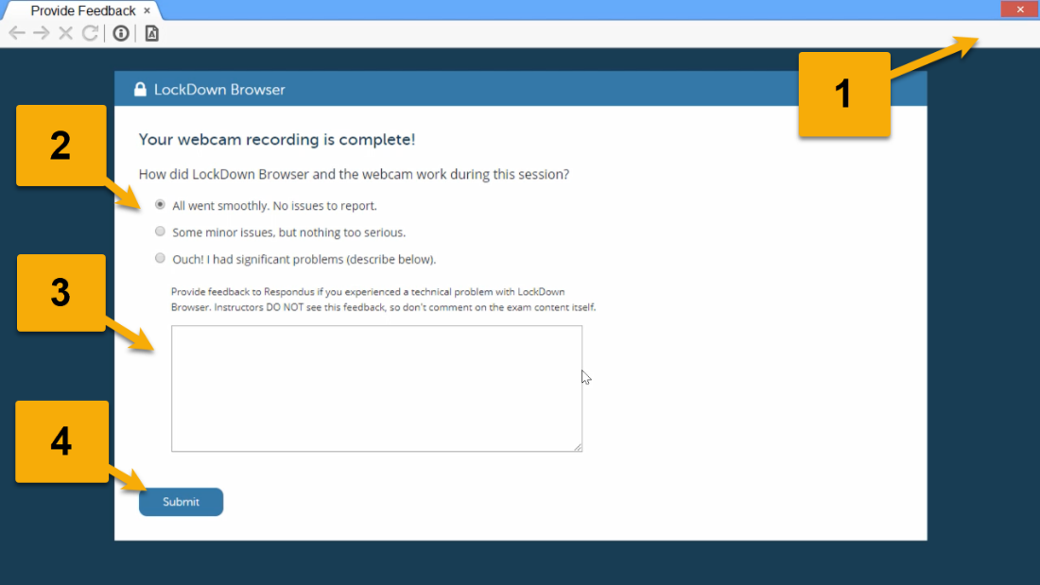

Review Results
- Review the details of your most recent attempt on the right-hand side.
  - If there were any short answer questions, your instructor will need to grade those before you see your final score.
  - If you have more attempts remaining, you will need to exit LockDown Browser and open it again before you can take another attempt.
- When you are finished, click the “X” in the upper-right to exit LockDown Browser.
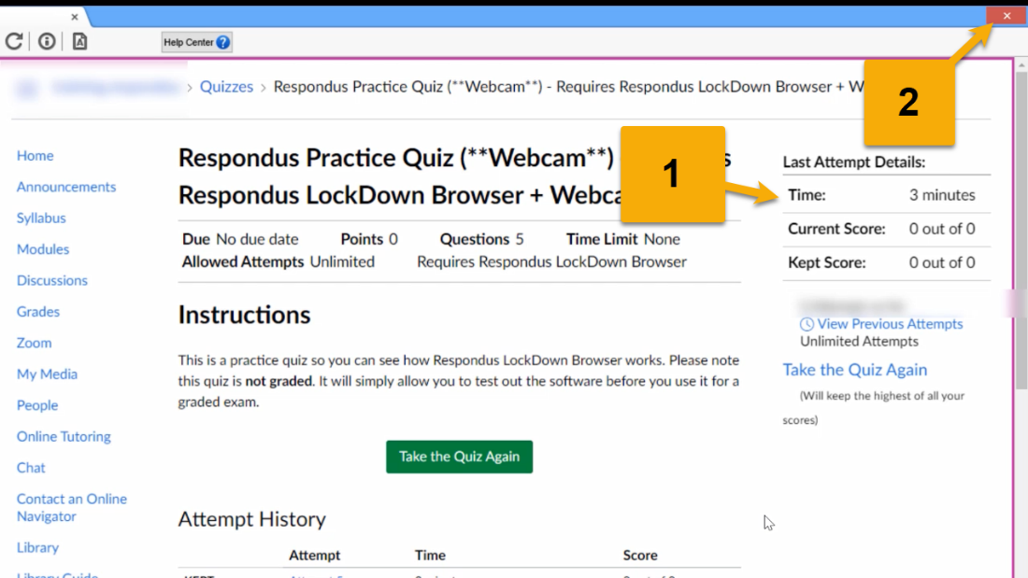

Exit LockDown Browser
- Click “Yes” to confirm you want to exit.
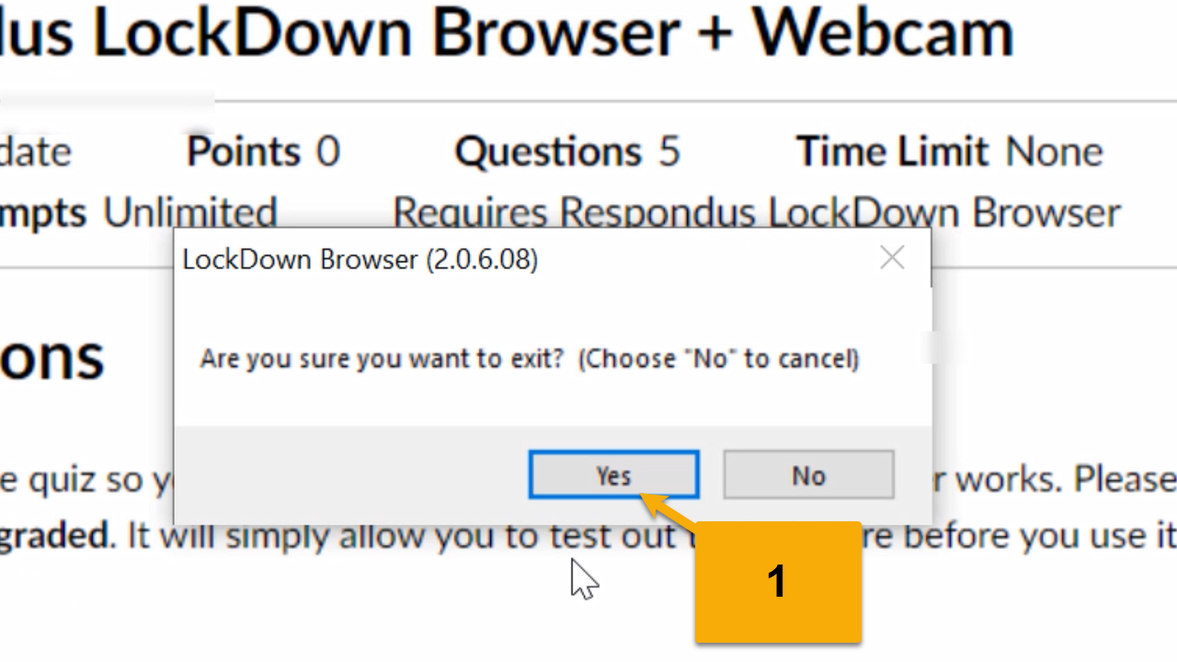
Additional Technical Support
If you are having difficulty with using Respondus LockDown Browser, you can contact the Wilmington University IT Help Desk. Contact information and support hours are available at wilmu.edu/techres
- It is recommended that you call 1-877-708-2905 or use the live chat.
- Be sure to contact during the support hours.
*Make sure you have a local admin account in order for them to be able to provide you with support.
